The Motherland: Experiences of Islam, Politics, and Culture In India

Part II: Self-Revelations: Discovering my Physiological Limits

As soon as I situated myself in Lucknow, I began discovering my physical, emotional, and psychological limits. Experiencing the bitter cold winters of Lucknow and her brutal summers really showed me how my body adjusted without a heater or air conditioner in each season respectively. I also unfortunately encountered the Indian health care system much sooner than I had expected.
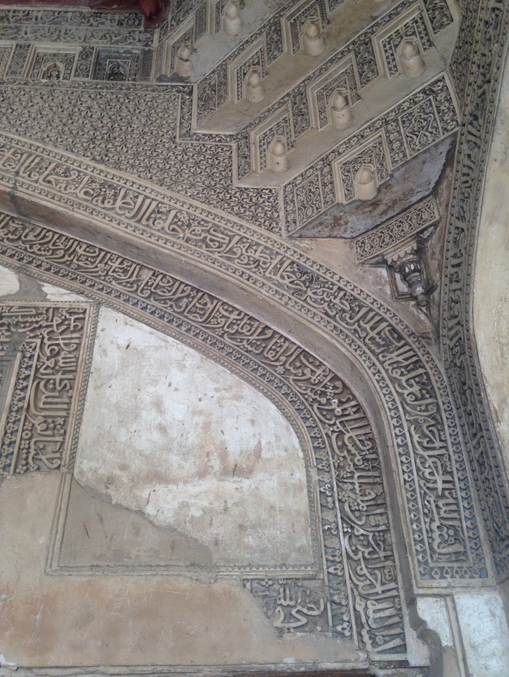
Stone carvings of Quran in mosques built by the Lodhi dysnasty in New Delhi.

Physical
In the first three months in Lucknow I lost between twenty-five to thirty pounds (11-13 kg) from just adjusting to the food, water, and weather. Americans are bound to lose weight simply by the nature of how people eat in India. Portions are smaller, food is more organic, oh, and not to mention the water. As soon as I settled into Nadwa (the shorter name for Nadwatul ‘Ulama), I started to drink the tap water of India. I had the typical daily (okay, twice) diarrhea for about three weeks, up until one morning I woke up and threw up like I have never thrown up in my life. I felt my stomach was going to come out of my throat. After that I was in bed for a week or so. But finally after recovering, drinking water from the tap became very easy for me--as did eating street food. As one of my friends said, “You now have a stomach of steel.” I knew I was going to be in India for a long time and decided that it would be most convenient to start getting used to living as others do over there. Getting bottled water was just too complicated after seeing cold taps available for drinking right next to your hostel.

The food situation was also quite tricky. After several failed attempts at having food delivered to me from outside tiffin services, I gave up and starting eating out for almost every meal. Since that became taxing as the weather got hotter and the cost of meals was adding up, I successfully started eating food from the madrasa which happened to taste quite pleasant. I received rice, bread, and lentils twice a day with a different curry dish each time. I still go out usually once a day to a local cafe just to unwind and get some comfort food. I spent a decent amount of time studying and eating at the Tramp Tree Café in Hazratganj (the sort of Times Square of Lucknow) which happened to be owned by India’s first MasterChef Pankaj Bhadouria.
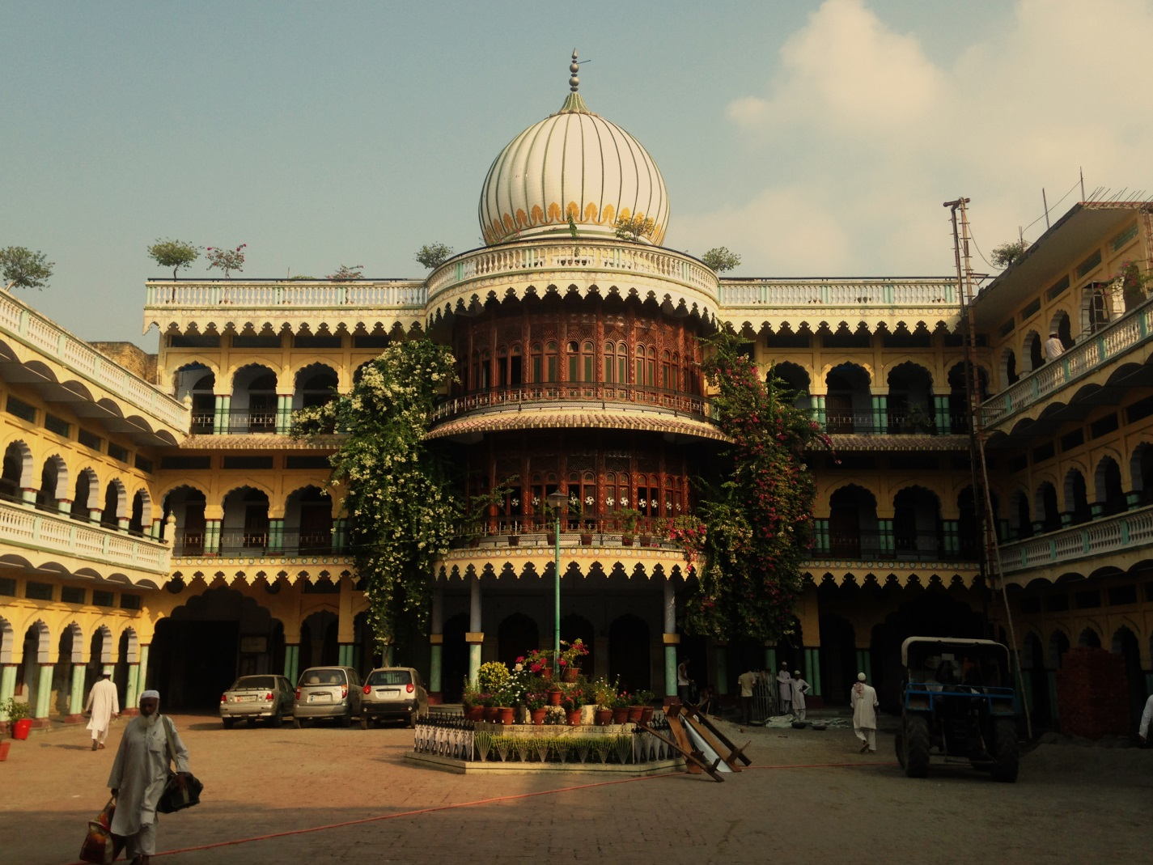
Figure 4: Mazahir al-Uloom in Saharanpur, Uttar Pradesh. The school where India's most senior teacher of hadith resides, Shaykh Yunus Saharanpuri.

Emotional/Psychological
When you think things cannot get any more ridiculous, leave it to the interactions of an American student with his Indian environment to prove him wrong. The biggest arena where this was tested was in my interactions with students and teachers alike at Nadwa. The most powerful incident which challenged my status quo was when I needed to get a measly managerial task completed; and instead of 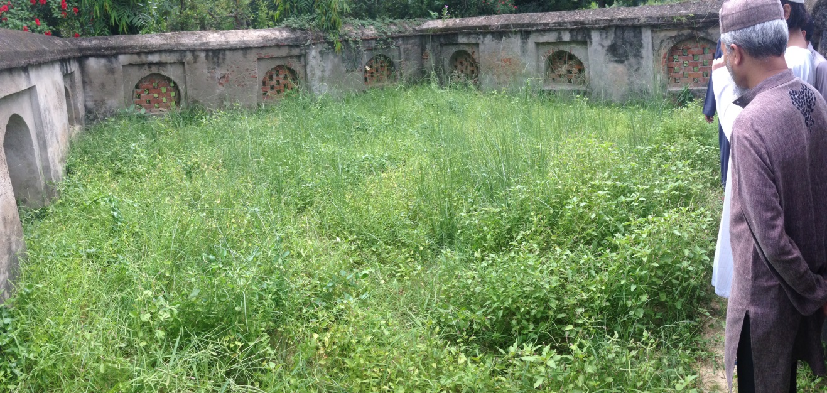
Rae Baraily (not to be confused with Baraily): The hometown and resting place of Shaykh Abul Hasan 'Ali al-Nadwi, the great writer and last rector of Nadwatul 'Ulama.
someone doing their job and getting done what needed to get done, there was a rather overbearing culture of purposeful procrastination that just seemed okay to do. It was one of those things which would make me angry, while also upsetting me to the extent of wanting to shed tears, but I would stop myself as there was absolutely no functional premise for me to do so. Crying would not get me anywhere. This was a big deal as many of these tasks need to be completed in succession to be able to either sit in classes, complete registration, get permission to travel during the school year, etc. When the same task could not get done, those feelings would not come back so strongly as they did the first time. I realized that my level of patience had gone up at that point, I had collected myself emotionally, and was now able to cognitively begin to analyze the environment that I was living in and its effect upon me. I will end up speaking more about this aspect in regards to interactions with students and teachers in the section below.

Weather in Lucknow: The Phrase "It's Really Hot Today" Redefined
Getting used to the climate in Lucknow was not as easy as I had imagined it to be. From May to August the heat is unbearable. The average temperature just in May was 110 degrees Fahrenheit with a 125 degree real feel. It only gets worse in June till August where the humidity sets in. Though the monsoon season also starts around this time sending cool rains to moisten and cool the air, these days the storms have been arriving very late.

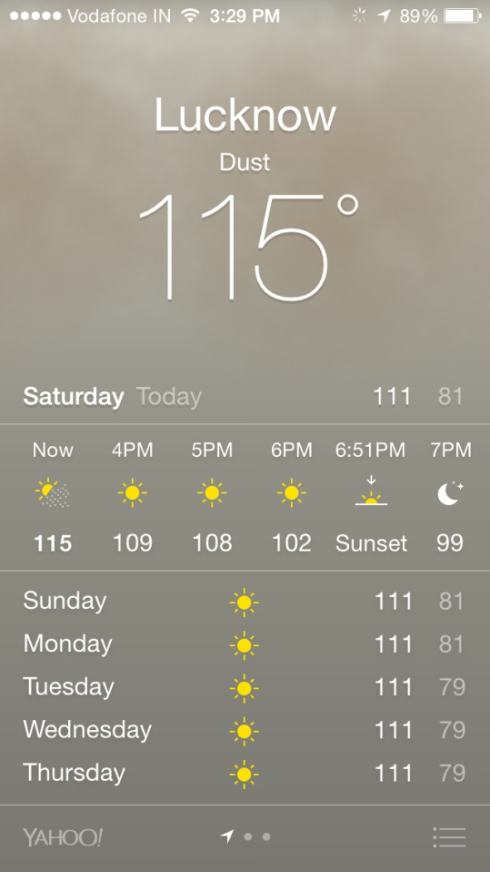
Things cool down between September to mid-December where it's between 80-90 degrees usually. Then from mid-December to January the temperature drops to 40 to below freezing for many days. Now though that does not sound too cold, you need to remember that there is no system of heating in most households and motor vehicles--so staying warm can be quite a challenge! Finally, from February to April the temperature is once again mild in the mid 80s during the day.
The real feel was 132 degrees Fahrenheit just about every day in May.

Stay tuned for Part III: Health Care in India: Scooters, Breaking Bones, and Surgery.

“Tiffins” generally refer to lunch boxes, but the tiffin can technically be used to deliver food any time of the day.

